Adrienne Bornemann

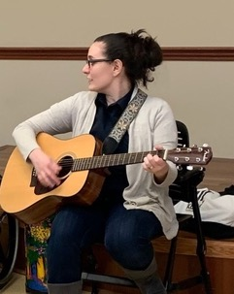

Adrienne has been making music and creating smiles at the KEYS Program as a music therapist since the Fall of 2018. She recently became the Music Therapy Director, helping to create and expand the music therapy program at KEYS. She graduated from Roberts Wesleyan College in May of 2008 with a degree in music education concentrating in flute; and graduated from Nazareth College with a Master of Science in Creative Arts Therapy, with a focus on music therapy in 2012. She is a board-certified music therapist and Licensed Creative Arts Therapist. She has been instrumental in developing and expanding the music program at KEYS, growing its outreach to include introducing new and creative music therapy programming for our KEYS kids, and expanding our outreach in the community to include serving special needs individuals, day programs and nursing homes.

