Desiree Murphy is an entertainment reporter, writer and editor living in Los Angeles, California.

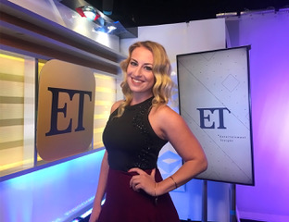
She currently works for Entertainment Tonight, conducting celebrity interviews for ETOnline.com and covering everything from breaking news stories to fan-favorite shows like "Dancing With the Stars," along with red carpet style for the Oscars, GRAMMYs, Golden Globes and more.
Originally from Rome, New York, Desiree always had big dreams of pursuing a career in entertainment. After graduating from RFA in 2007, she moved south to study journalism, fashion and dance at the University of South Carolina, simultaneously interning for magazines like Seventeen and Bridal Guide.
Just two weeks after college graduation, Desiree packed her bags and moved to Los Angeles to begin her professional career as a writer/reporter for Tiger Beat and BOP magazines. She was promoted to Executive Editor within just three years before landing her current job with ET in 2015.
During her 10 years in Hollywood, Desiree's interviewed celebrities on some of Hollywood's most notable awards show red carpets (including the GRAMMYs, American Music Awards, MTV Video Music Awards, MTV Movie Awards, Kids' Choice Awards, People's Choice Awards and the Teen Choice Awards) and movie premieres ("Justin Bieber: Believe," "Katy Perry: Part of Me," "The Hunger Games").
Some of her favorite memories include: Bringing her yorkie, Peanut, to a photo shoot with Ariana Grande, personally getting serenaded by Kelly Clarkson and introducing her dad to her #1 Hollywood crush, Channing Tatum.

