John Carmody

John Carmody was born in Rome, N. Y. in 1951. He has lived in Rome for all of his 70 years. After attending Rome City schools he graduated from RFA with the class of 1969. He married his high school sweetheart, Laura Swift, in 1972. They raised 2 daughters; Heather and Jennifer. Jennifer has blessed them with 2 grandchildren.
John earned a BA in history from Utica College, a Masters Degree in Social Studies Education from Syracuse University, and a Masters Degree in Special Education from the College of Saint Rose. He is a retired special education teacher having taught at the House of the Good Shepherd, Camden High School, and the Holland Patent School District.
John's parents instilled in him at an early age a love for history, especially colonial and military history. In 2011, he helped to organize the Fort Bull Research Group. This organization is dedicated to preserving the history of the Great Oneida Carrying Place and to educating the public of its history.

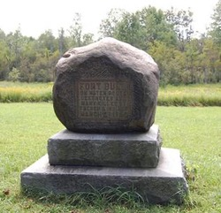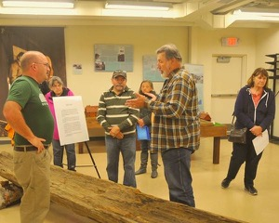

Photo on left is monument to Fort Bull. The photo on the right is the Fort Bull Research Group photo during a lecture the group did at Roger’s Island.

